PROJECT REPORT
ON

SMART RIDER SAFETY AND ACCIDENT DETECTION SYSTEM
SUBMITTED IN PARTIAL FULFILLMENT OF
THE REQUIREMENTS OF THE AWARD OF THE

PG-Diploma in Embedded System Design

Offered By
C-DAC Hyderabad
BY

MATTAPARTHI KUMAR GUPTA | 250850330034
METTA HEMA NAGA LOHITHA | 250850330035
MOHAMMAD NAFISA | 250850330036



Advanced Computing Training School C-DAC
Hyderabad-500005
August 2025

CERTIFICATE

This is to certify that this is a Bonafide record of project entitled “Smart Rider Safety and Accident Detection System”. Mattaparthi Kumar Gupta (250850330034), Metta Hema Naga Lohitha (250850330035) and Mohammad Nafisa (250850330036) completed project work as part of Diploma in Embedded System Design (August, 2025-Batch), a PG course offered by C-DAC Hyderabad. They have completed project work under the supervision of Mr. Sahil. Their Performance was found to be good.

Signature of Project guide
(Mr. Sahil)

Date: 06-02-2026
Place: C-DAC, HARDWARE PARK, HYDERABAD.

ACKNOWLEDGMENT

Smart Rider Safety and Accident Detection System has been presented. This project marks the final hurdle that we tackle, of hopefully what would be one of the many challenges we have taken upon and are yet to take. However, we could not have made it without the support and guidance from the following. Firstly, I express my sincere and heartfelt gratitude to Mr. Sahil who has guided me in completing the project with his cooperation, valuable guidance and immense help in giving the project a shape and success. I am very much indebted to him for suggesting a challenging and interactive project and his valuable advice at every stage of this work.

PG-DESD February 2025

MATTAPARTHI KUMAR GUPTA | 250850330034
METTA HEMA NAGA LOHITHA | 250850330035
MOHAMMAD NAFISA | 250850330036

TABLE OF CONTENTS

ABSTRACT
- Introduction
  - Problem Statement
  - Software & Hardware Requirements
    - Hardware Specification
    - Software Specification
  - Coding and Testing
- Implementation
  - ESP32 Dev Module
  - MPU6050 Module
  - HC-SR501 PIR Motion Module
  - Eye Blink Module
  - MQ-3 Module
  - GPS NEO-7M Module
  - 5V Relay Module with Optocoupler
  - Active Buzzer
  - 12 V Li-ion Battery
  - 1000 RPM DC Motor
2.11 Arduino IDE
- Application Code
- Implementation Diagram
  - Schematic Diagram
  - Cloud Output
- Flow of project work
- Literature Survey
- Conclusion
- Reference

ABSTRACT

The Smart Rider Safety and Accident Detection System is designed to improve two-wheeler rider safety using embedded systems and IoT technology. The system consists of two ESP32 microcontrollers—one installed in the helmet unit and the other in the bike unit—communicating through the ESP-NOW protocol for fast and reliable wireless data transfer without requiring internet connectivity. The helmet unit monitors rider-related safety conditions, while the bike unit manages ignition control, accident detection, and emergency communication.
The helmet unit integrates an eye-blink sensor to detect drowsiness and the MQ-3 to identify alcohol consumption. If unsafe conditions are detected, the information is transmitted to the bike unit via ESP-NOW, and the system restricts vehicle ignition or generates warning alerts. The bike unit incorporates the MPU-6050 sensor to monitor sudden impacts and abnormal tilt angles for accident detection. A helmet detection mechanism ensures that the vehicle starts only when the rider is wearing the helmet.
In the event of an accident, the bike unit automatically sends an emergency alert message along with location details to predefined contact numbers using the Twilio SMS service over Wi-Fi. This immediate notification reduces response time and increases the chances of timely medical assistance. The proposed system provides a modular, scalable, and intelligent solution that enhances road safety by integrating dual ESP32 architecture, ESP-NOW communication, real-time monitoring, and automated emergency alerts.

INTRODUCTION

Problem Statement:
Road accidents are one of the leading causes of injuries and fatalities worldwide, particularly among two-wheeler riders who lack structural protection during collisions. A large number of accidents occur due to unsafe riding behaviors such as alcohol consumption, rider drowsiness, overspeeding, and failure to wear a helmet. These factors significantly increase both the probability of accidents and the severity of injuries. Furthermore, many accident victims do not receive timely medical assistance because incidents remain unreported for extended periods, especially when riders are unconscious or unable to seek help. This delay in emergency response greatly reduces survival chances and highlights the need for an intelligent safety monitoring system.
Existing safety mechanisms mainly focus on passive protection rather than real-time prevention and automatic accident reporting. There is a lack of an integrated system that can simultaneously monitor rider behavior, enforce helmet usage, detect accidents instantly, and communicate emergency information automatically. Therefore, there is a strong need for a smart, embedded, and IoT-based solution that can actively prevent unsafe riding conditions while ensuring immediate alert generation during emergencies.
To address these challenges, the proposed Smart Rider Safety and Accident Detection System utilizes dual ESP32 microcontrollers communicating through the ESP-NOW protocol for reliable wireless data transfer. The helmet unit monitors rider alertness using an eye-blink sensor and detects alcohol consumption using the MQ-3, while the bike unit employs the MPU-6050 accelerometer and gyroscope to identify sudden impacts or abnormal tilts. A helmet detection mechanism ensures that the vehicle ignition is enabled only when the rider is wearing a helmet. In the event of an accident, the system automatically sends an emergency alert message with location details to predefined contacts using the Twilio service, thereby reducing response time and improving overall rider safety.

Software & Hardware Requirements:

Hardware Specification:
        - ESP32 Dev Module
        - MPU6050 Module
        - HC-SR501 PIR motion Module
        - Eye Blink Module
        - MQ-3 Module
        - GPS NEO-7M Module
        - Buzzer
        - 5V Relay Module with Optocoupler
        - Power Supply (12V Li-ion Battery)
        - 1000 RPM DC Motor
        - Jumper Wires & Breadboard/PCB

Software Specification:
- IDE: Arduino IDE

Coding and Testing:
- Embedded C programming language

IMPLEMENTATION
The Smart Rider Safety and Accident Detection System is implemented using dual ESP32 microcontrollers as the core processing units, integrating multiple safety sensors to ensure real-time monitoring and accident prevention. The system is divided into two modules: a helmet unit and a bike unit, which communicate wirelessly using the ESP-NOW protocol for fast and reliable data exchange without requiring continuous internet connectivity. The helmet unit monitors rider-related parameters such as alcohol consumption and drowsiness, while the bike unit manages ignition control, accident detection, and emergency communication.
The helmet unit incorporates the MQ-3 to detect alcohol levels and an eye-blink sensor to monitor rider alertness. If unsafe conditions are detected, the helmet ESP32 transmits warning signals to the bike unit via ESP-NOW. The bike unit integrates the MPU-6050 accelerometer and gyroscope to detect sudden impacts and abnormal tilts that indicate accident events. A helmet detection mechanism and relay-based ignition control system ensure that the vehicle starts only when safety conditions are satisfied.
For emergency response, the bike unit connects to Wi-Fi and utilizes the Twilio service to send SMS alerts containing location details to predefined contact numbers in the event of an accident. The system logic is developed using the Arduino IDE, where threshold values and decision algorithms are implemented to ensure accurate detection and reliable operation. This integrated hardware-software architecture provides a scalable, cost-effective, and intelligent safety solution for two-wheeler riders.

ESP32 Dev Module:
ESP32 is a low-cost System on Chip (SoC) Microcontroller from Espressif Systems, the developers of the famous ESP8266 Soc. It is a successor to ESP8266 SoC and comes in both single-core and dual-core variations of the Tensilica’s 32-bit Xtensa LX6 Microprocessor with integrated Wi-Fi and Bluetooth. The good thing about ESP32, like ESP8266 is its integrated RF components like Power Amplifier, Low-Noise Receive Amplifier, Antenna Switch, Filters and RF Balun. This makes designing hardware around ESP32 very easy as you require very few external components. Another important thing to know about ESP32 is that it is manufactured using TSMC’s ultra-low- power 40 nm technology. So, designing battery operated applications like wearables, audio equipment, baby monitors, smart watches, etc., using ESP32 should be very easy.
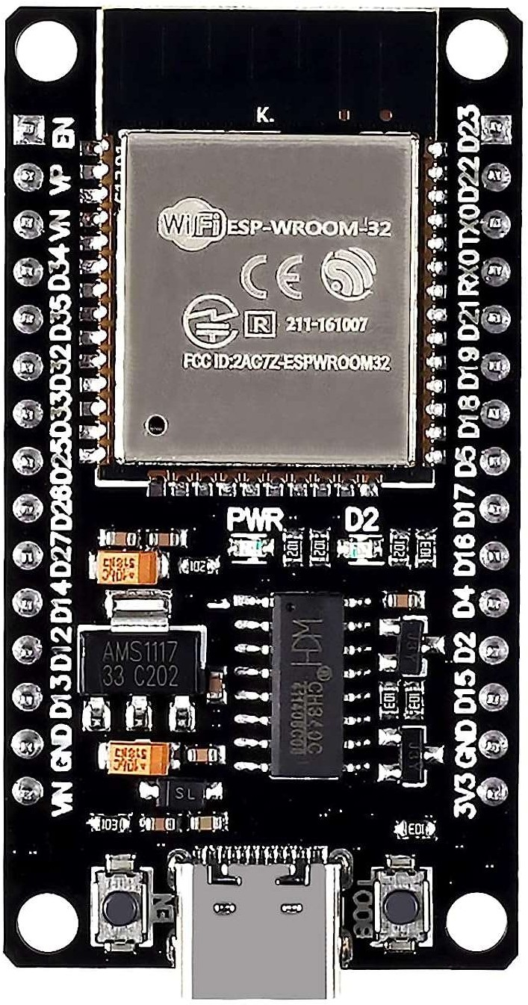
Fig 3.2.1: ESP32 board

Specifications of ESP32:
ESP32 has a lot more features than ESP8266 and it is difficult to include all the specifications in this Getting Started with ESP32 guide. So, I made a list of some of the important specifications of ESP32 here. But for complete set of specifications, I strongly suggest you refer to the Datasheet.
Single or Dual-Core 32-bit LX6 Microprocessor with clock frequency up to 240 MHz’s, 520 KB of SRAM, 448 KB of ROM and 16 KB of RTC SRAM. Supports 802.11 b/g/n Wi-Fi connectivity with speeds up to 150 Mbps. Support for both Classic Bluetooth v4.2 and BLE specifications. 34 Programmable GPIOs up to 18 channels of 12-bit SAR ADC and 2 channels of 8-bit DAC Serial Connectivity include 4 x SPI, 2 x I2C, 2 x I2S, 3 x UART. Ethernet MAC for physical LAN Communication (requires external PHY).
With the above specifications in front of you, it is very easy to decipher the reasons for ESP32's popularity. Consider the requirements an IoT device would have from its microcontroller (μC). If you've gone through the previous chapter, you'd have realized that the major operational blocks of any IoT device are sensing, processing, storage, and transmitting. Therefore, to begin with, the μC should be able to interface with a variety of sensors. It should support all the common communication protocols required for sensor interface: UART, I2C, SPI. It should have ADC and pulse counting capabilities. ESP32 fulfils all of these requirements. On top of that, it also can interface with capacitive touch sensors. Therefore, most common sensors can interface seamlessly with ESP32.

Secondly, the μC should be able to perform basic processing of the incoming sensor data, sometimes at high speeds, and have sufficient memory to store the data. ESP32 has a max operating frequency of 40 MHz, which is sufficiently high. It has two cores, allowing parallel processing, which is a further add-on. Finally, its 520 KB SRAM is sufficiently large for processing a large array of data on board. Many popular processes and transforms, like FFT, peak detection, RMS calculation, etc. can be performed on board ESP32. On the storage front, ESP32 goes a step ahead of the conventional microcontrollers and provides a file system within the flash. Out of the 4 MB of on-board flash, by default, 1.5 MB is reserved as SPIFFS (SPI Fla sh File System). Think of it as a mini−SD Card that lies within the chip itself. You can not only store data, but also text files, images, HTML and CSS files, and a lot more within SPIFFS. People have displayed beautiful Webpages on Wi- Fi servers created using ESP32, by storing HTML files within SPIFFS.
Finally, for transmitting data, ESP32 has integrated Wi-Fi and Bluetooth stacks,
which have proven to be a game-changer. No need to connect a separate module (like a GSM module or an LTE module) for testing cloud communication. Just have the ESP32 board and a running Wi-Fi, and you can get started. ESP32 allows you to use Wi-Fi in Access Point as well as Station Mode. While it supports TCP/IP, HTTP, MQTT, and other traditional communication protocols, it also supports HTTPS.
So, you cannot only communicate with your web server, you can do so securely. BLE support is also critical for several applications. Of course, you can interface LTE or GSM or LoRa modules with ESP32. Therefore, on the 'transmitting data' front as well, ESP32 exceeds expectations.
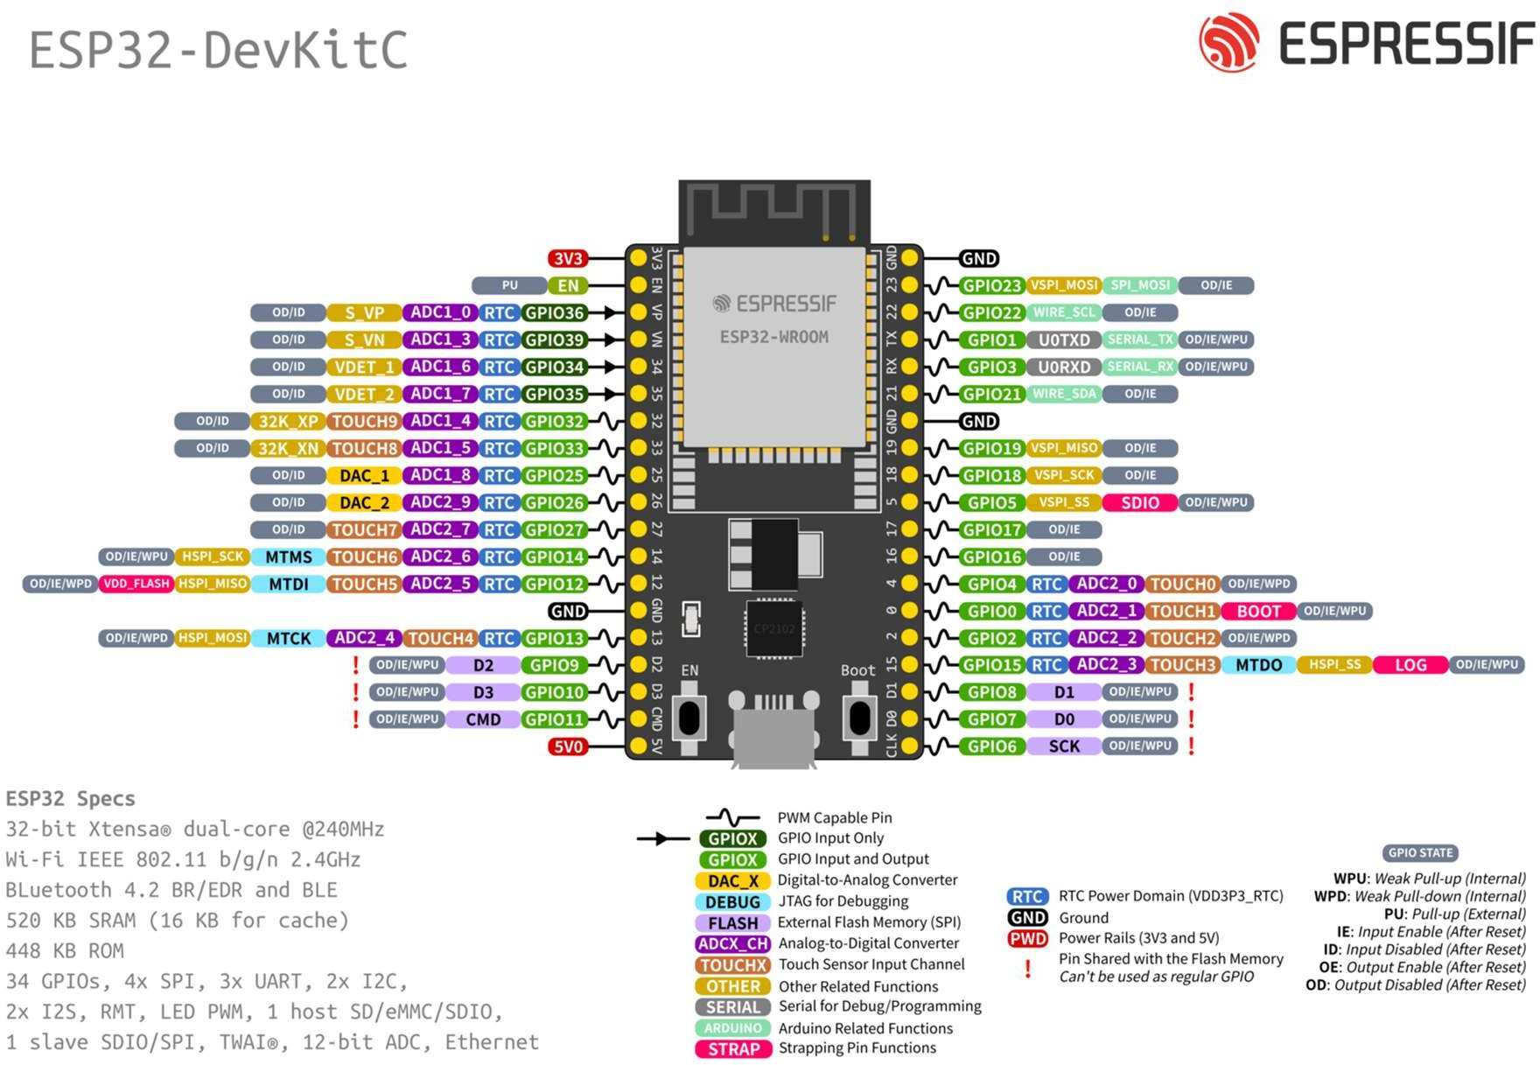
With these many features and still ESP32 is cheaper than other modules. Not only that, the chip dimensions are also quite small (25 mm x 18 mm, including the antenna area), allowing the use in devices requiring a very small form factor. Finally, ESP32 can be programmed using the Arduino IDE, making the learning curve much less steep.

MPU6050 Module
The MPU6050 is a 6-axis Motion Tracking Device developed by InvenSense. It combines a 3-axis accelerometer and a 3-axis gyroscope in a single chip. The sensor is widely used in embedded systems, robotics, drones, wearable devices, and accident detection systems due to its compact size, low cost, and high accuracy.
The MPU6050 communicates using the I2C protocol and includes an internal Digital Motion Processor (DMP) that performs sensor fusion calculations. This reduces the processing load on the microcontroller and improves motion analysis accuracy.

Working Principle:
- Accelerometer Working
The accelerometer measures linear acceleration along three axes: X, Y, and Z. It works based on MEMS (Micro Electro Mechanical Systems) technology. Inside the sensor, tiny mechanical structures move when acceleration occurs. This movement changes capacitance, which is converted into digital signals.
The accelerometer can measure acceleration in selectable ranges:
±2g
±4g
±8g
±16g
Where 1g = 9.8 m/s².
It is used to detect:
Sudden impact
Free fall
Tilt angle
Vibration
B. Gyroscope Working
The gyroscope measures angular velocity (rate of rotation) around X, Y, and Z axes. It also uses MEMS technology to detect rotational motion.
Selectable ranges:
±250°/s
±500°/s
±1000°/s
±2000°/s
It is used to detect:
Sudden bike rotation
Skidding
Abnormal tilt
Crash movement
C. Digital Motion Processor (DMP)
The MPU6050 contains an internal DMP which:
Performs sensor fusion
Filters noise
Calculates orientation
Generates quaternion data
This improves motion tracking accuracy and reduces microcontroller computation.

Key Features:
- 6-axis motion tracking (3-axis accelerometer + 3-axis gyroscope)
- Built-in 16-bit ADC
- I2C communication interface
- Internal Digital Motion Processor (DMP)
- Built-in temperature sensor
- Low power consumption
- Programmable full-scale range
- Compact size and low cost

Technical Specifications:

Gyroscope Specifications

Parameter | Specification
Full-Scale Range | ±250, ±500, ±1000, ±2000 °/s
ADC Resolution | 16-bit
Sensitivity | 131, 65.5, 32.8, 16.4 LSB/(°/s)
Sensitivity Tolerance | ±3%
Non-Linearity | 0.2%
Cross-Axis Sensitivity | ±2%
Output Data Rate | 4 Hz – 8 kHz
Low Pass Filter | 5 Hz – 256 Hz
Start-Up Time | 30 ms
Noise Density | 0.005 °/s/√Hz
RMS Noise (±250°/s) | 0.05 °/s-rms

Accelerometer Specifcatioins
Parameter | Specification
Full-Scale Range | ±2g, ±4g, ±8g, ±16g
ADC Resolution | 16-bit
Sensitivity | 16384, 8192, 4096, 2048 LSB/g
Calibration Tolerance | ±3%
Nonlinearity | 0.5%
Cross-Axis Sensitivity | ±2%
Output Data Rate | 4 Hz – 1 kHz
Low Pass Filter | 5 Hz – 260 Hz
Noise Density | 400 µg/√Hz
Zero-g Offset | ±50 mg (X/Y), ±80 mg (Z)

Electrical Specifications
Parameter | Specification
Operating Voltage (VDD) | 2.375 V – 3.46 V
Logic Voltage (VLOGIC) | 1.71 V – VDD
Operating Current (Full Operation) | 3.9 mA
Gyroscope Current | 3.6 mA
Accelerometer Current | 500 µA
Low Power Mode Current | 10 – 140 µA
Idle Mode Current | 5 µA

Temperature Sensor
Parameter | Specification
Operating Range | –40°C to +85°C
Sensitivity | 340 LSB/°C
Accuracy | ±1°C

Communication & Physical Details
Parameter | Specification
Interface | I²C
I²C Address | 0x68 / 0x69
Package | 24-pin QFN
Dimensions | 4 mm × 4 mm × 0.9 mm
Shock Tolerance | 10,000 g

Pin Configuration:
Pin | Description
VCC (VDD) | 3.3V power supply input to the sensor
GND | Ground connection (common ground with controller)
SDA | I2C Serial Data line for communication
SCL | I2C Serial Clock line for communication
INT | Interrupt output for motion/impact detection (optional)
AD0 | I2C address selection pin (LOW = 0x68, HIGH = 0x69)
XDA | Auxiliary I2C data line (optional)
XCL | Auxiliary I2C clock line (optional)

Advantages:
- Combines 3-axis accelerometer and 3-axis gyroscope (6-axis sensor).
- High 16-bit resolution for accurate motion detection.
- Compact and lightweight design.
- Low power consumption.
- Programmable sensitivity ranges.
- Built-in Digital Motion Processor (DMP).
- Easy I²C interface with microcontrollers.
- Cost-effective and widely available.

Limitations:
- No built-in magnetometer (only 6-axis, not 9-axis).
- Sensitive to vibrations and noise.
- Requires calibration for accurate results.
- Drift errors may occur in gyroscope readings.
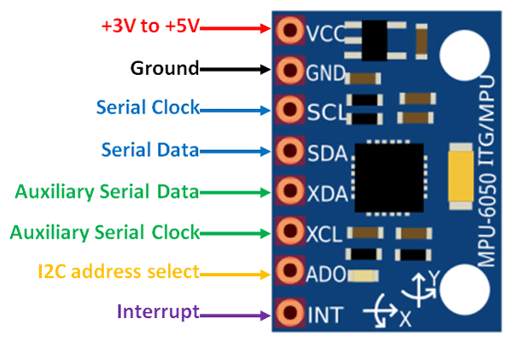
- Limited to I²C communication (no SPI in MPU6050 version).

PIR Motion module

A PIR (Passive Infrared) Motion Sensor is an electronic device used to detect motion by sensing changes in infrared (IR) radiation. All living objects emit infrared radiation based on their body temperature. The PIR sensor detects variations in this IR radiation when a human or animal moves within its detection range.
It is widely used in security systems, automatic lighting, intrusion detection, and smart embedded applications due to its low cost and low power consumption.

Key Features:

Passive infrared motion detection

Detection range up to 7 meters

Wide sensing angle (~110°)

Adjustable delay time

Repeatable / non-repeatable trigger modes

Low power consumption

3.3V TTL digital output

Compact and easy to interface

Working Principle:

The PIR sensor works based on infrared radiation detection.

It contains a pyroelectric sensor that detects changes in infrared energy.

When a human body passes in front of the sensor, the IR radiation level changes.

This change generates a small electrical signal.

The internal amplifier and comparator convert this into a digital HIGH output signal.

The sensor does not emit radiation; it only detects IR energy — hence the name Passive Infrared Sensor.

Technical Specifications:
Parameter | Specification
Operating Voltage | DC 4.5V – 20V
Quiescent Current | < 50 µA
Power Consumption | Approx. 65 mA (active)
Output Voltage Level | High: 3.3V, Low: 0V (TTL Output)
Trigger Modes | L: Non-repeatable trigger, H: Repeatable trigger (Default)
Delay Time | Adjustable (0.3 sec – 300 sec approx.)
Block Time | 2.5 sec (default, adjustable)
Sensing Distance | Up to 7 meters
Detection Angle | < 110° cone angle
Operating Temperature | -15°C to +70°C
Board Dimensions | 32 mm × 24 mm
Lens Diameter | 23 mm (default)

Pinout & Interfaces:

Pin | Function
VCC | Power supply input (4.5V – 20V DC)
OUT | Digital output (High = Motion detected, Low = No motion)
GND | Ground connection

Advantages:

Low power consumption

Easy to interface with microcontrollers

Cost-effective and widely available

Simple digital output (HIGH/LOW)

Wide detection range and angle

Compact and lightweight

Reliable for human motion detection

Limitations:
- Cannot detect stationary objects
- Sensitive to temperature changes
- False triggering due to heat sources (sunlight, lamps)
- Limited detection range (only a few meters)
- Cannot detect objects through walls or glass
- Delay in response time due to adjustable timing.

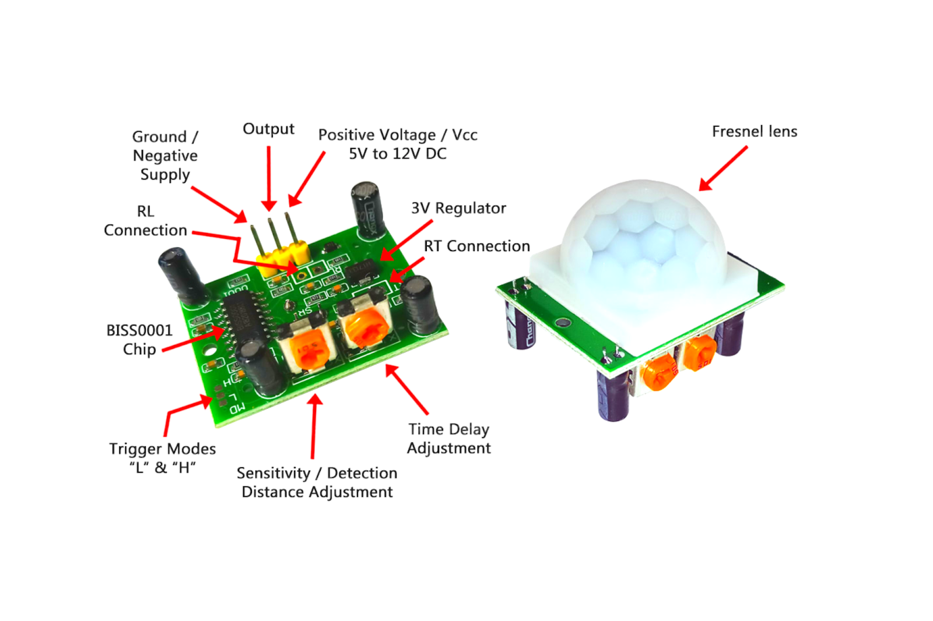

Eye Blink Module
An Eye Blink Sensor is a simple electronic device used to detect whether a person’s eye is open or closed. It mainly uses infrared (IR) technology to monitor eye movements and blinking. The sensor is usually mounted on a pair of glasses so that it can directly align with the user’s eye.

Construction & Working Principle:

The eye blink sensor works based on infrared light reflection.

It consists of two main parts:

IR Emitter (LED)

IR Receiver (Photodiode)

The IR emitter sends infrared light toward the eye.

The photodiode receives the reflected light.

Operation:

Eye Open → IR light is absorbed or scattered → Low reflection

Eye Closed (Blink) → IR light reflects strongly → High reflection

Key Features:
- Uses infrared technology
- Provides digital output
- Adjustable sensitivity
- Easy to interface with microcontrollers
- Compact and wearable design.

Technical Specifications:
Parameter | Specification
Operating Voltage | 3.3V – 5V
Output Type | Digital (HIGH/LOW)
Sensor Type | Infrared (IR) based
Detection Method | Reflection of IR light
Response Time | Fast (real-time detection)
Sensing Range | Few centimeters (close to eye)
Sensitivity Adjustment | Available (via potentiometer)
Power Consumption | Low
Operating Condition | Requires proper alignment with eye

Pinout / Connections:
A typical 4×4 membrane keypad has 8 pins:
Pin | Function
VCC | Power supply input (3.3V–5V)
GND | Ground connection
OUT | Digital output signal (HIGH when eye blink detected, LOW otherwise)

Advantages:

Simple and low-cost sensor

Non-contact detection

Easy to integrate with Arduino/ESP32

Suitable for real-time monitoring

Limitations:

Sensitive to ambient light interference

Requires proper alignment with eye

Limited accuracy in bright environments

Not suitable for highly precise medical use

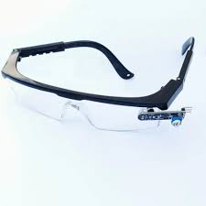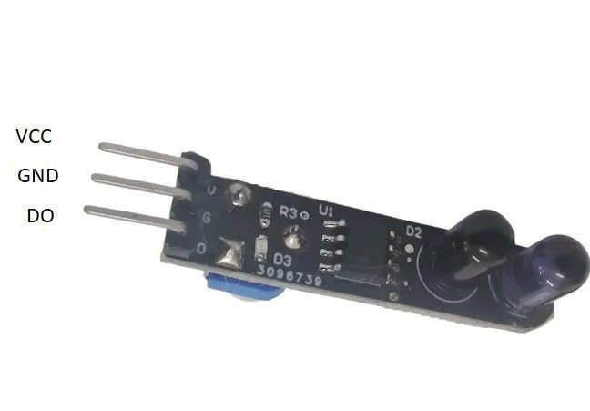

MQ-3 Module
The MQ-3 is a gas sensor specifically designed to detect alcohol (ethanol) concentration in the air. It is widely used in breath analyzers, safety systems, and embedded applications. The sensor is highly sensitive to alcohol and has low sensitivity to other gases, making it suitable for alcohol detection systems.

Working Principle:

The MQ-3 sensor works based on gas sensing using a heated tin dioxide (SnO₂) semiconductor layer.

The sensor contains a heating element and a sensing material (SnO₂).

In clean air → sensor resistance is high.

When alcohol gas is present → resistance decreases.

This change in resistance is converted into a voltage output.

Operation:

Alcohol present → conductivity increases

Output signal changes → detected by microcontroller

Key Features:
- High sensitivity to alcohol
- Fast response and recovery time
- Simple analog and digital output
- Adjustable sensitivity (via potentiometer)
- Long life and low cost
- Easy interfacing with microcontrollers

Technical Specifications:
Parameter | Specification
Detection Range | 0.05 mg/L to 10 mg/L
Output Type | Analog and Digital
Preheat Time | ~20 seconds (minimum)
Operating Temperature | -10°C to +50°C
Power Consumption | < 800 mW

Pin Configurations:
Pin | Description
VCC | Power supply (5V)
GND | Ground
AOUT | Analog output (proportional to alcohol level)
DOUT | Digital output (HIGH/LOW based on threshold)
VCC | Power supply (5V)

Advantages
- Low cost and easily available
- High sensitivity to alcohol
- Simple circuit design
- Analog + digital outputs
- Reliable for real-time detection

Limitations
- Requires preheating time
- Sensitive to temperature and humidity
- Not highly accurate for precise measurements
- Can detect other gases slightly
- Needs calibration for accurate results

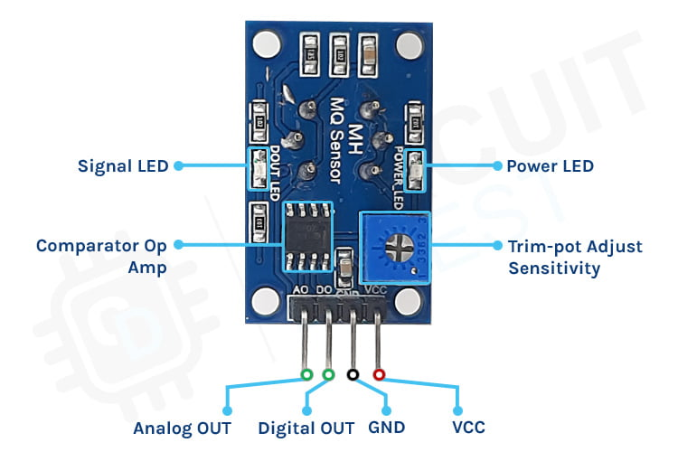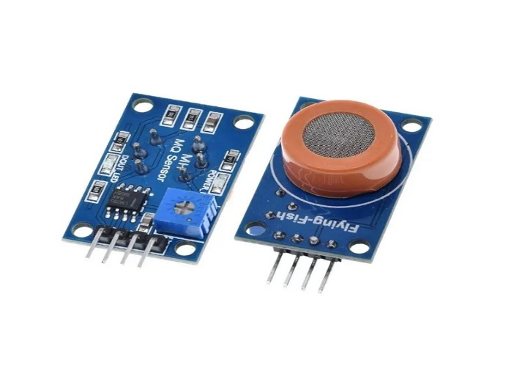

2.6 NEO-7M GPS Module
The NEO-7M GPS module is a high-performance Global Positioning System (GPS) receiver module developed by u-blox. It is used to determine the precise location (latitude, longitude, altitude) of a device using satellite signals.
The NEO-7M module is widely used in embedded systems, tracking devices, navigation systems, and IoT applications due to its accuracy, low power consumption, and ease of interfacing.

Working Principle
The GPS NEO-7M works based on satellite communication.
- It receives signals from multiple GPS satellites orbiting the Earth.
- Each satellite sends time and position data.
- The GPS module calculates the distance from satellites using signal travel time.
- Using data from at least 4 satellites, it determines:
  - Latitude
  - Longitude
  - Altitude
This process is called trilateration.
Key Features
- High sensitivity GPS receiver
- Fast positioning (quick start time)
- Low power consumption
- Supports multiple satellite tracking
- Built-in antenna (or external antenna support)
- UART communication interface
- High accuracy positioning

Technical Specifications
Parameter | Specification
Operating Voltage | 3.3V – 5V
Position Accuracy | ~2.5 meters
Communication Interface | UART (Serial)
Update Rate | 1 Hz (default, up to 5 Hz)
Sensitivity | -161 dBm
Cold Start Time | ~27 seconds
Hot Start Time | ~1 second
Operating Temperature | -40°C to +85°C
Power Consumption | ~45 mA

Pin Configurations
Pin | Description
VCC | Power supply (3.3V–5V)
GND | Ground
TX | Transmit data (GPS → ESP32)
RX | Receive data (ESP32 → GPS)
Advantages
- High positioning accuracy
- Easy UART interfacing
- Compact and low cost
- Reliable satellite tracking
- Suitable for real-time applications
Limitations
- Requires clear sky view for accuracy
- Slower response during cold start
- Signal loss in indoor environments
- Power consumption higher than simple sensors

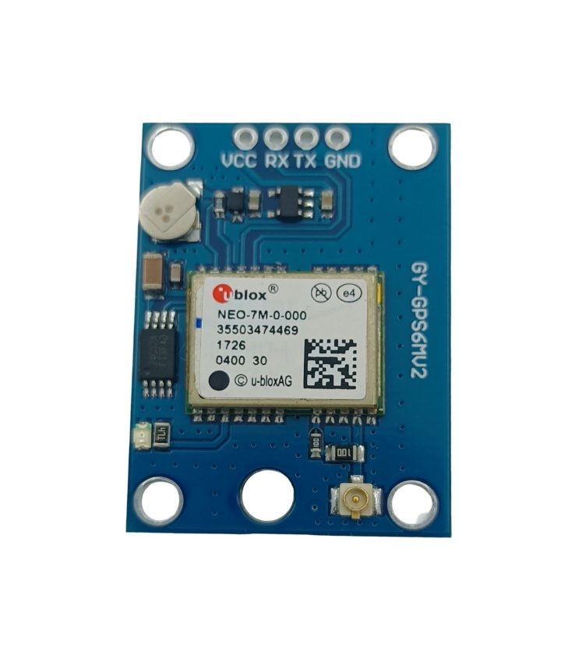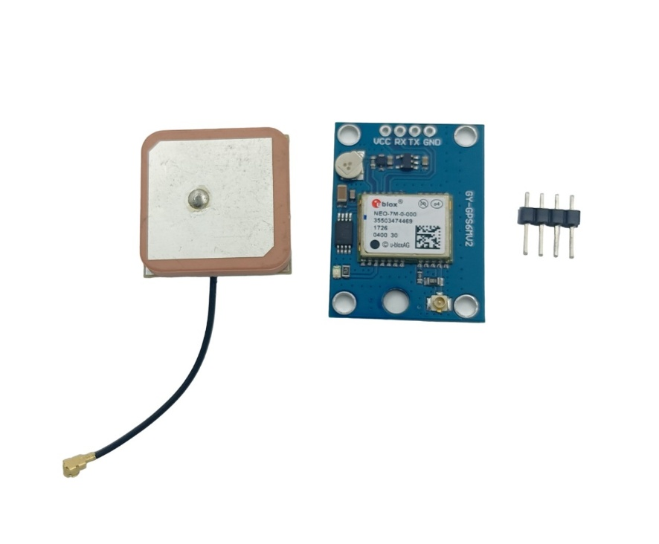

2.7 5V Relay module with Optocoupler
A 5V Relay Module is an electromechanical switching device used to control high-voltage or high-current loads using low-voltage control signals (typically from microcontrollers like Arduino, ESP32, Raspberry Pi, etc.). It provides electrical insulation between the control circuit and the load, making it ideal for safely switching AC appliances or DC loads from digital systems.

Working Principle:
The relay module contains:
- A 5V electromagnetic relay
- A driver transistor
- A flyback diode for coil protection
- Often an optocoupler for isolation
- Status indicator LED

When a 5V control signal is applied to the input pin:
- The relay coil gets energized.
- A magnetic field pulls the internal switch.
- The COM terminal connects to NO (Normally Open) or disconnects from NC (Normally Closed).
- When the signal is removed, the relay returns to its default state.
This allows a low-power controller to safely switch high-power devices.

Key Features:
- 5V DC control voltage
- Electromechanical isolation between control and load
- Can switch AC or DC loads
- Optocoupler isolation (on many models)
- Indicator LED for relay status
- Available in 1-channel, 2-channel, 4-channel, and 8-channel versions
- Supports active HIGH or active LOW triggering (module dependent)

Technical Specifications:
Parameter | Specification
Relay Type | Electromechanical (SPDT)
Control Voltage | 5 V DC
Trigger Voltage | 3.3–5 V logic compatible
Coil Current | ~70–90 mA (per relay)
Switching Voltage (AC) | Up to 250 V AC
Switching Voltage (DC) | Up to 30 V DC
Max Switching Current | 10 A
Contact Configuration | COM, NO, NC
Isolation | Optocoupler (model dependent)
Indicator | Onboard LED
Response Time | ~10 ms
Release Time | ~5 ms
Operating Temperature | −10 °C to +60 °C
Module Dimensions | Varies by channel count

Pin Configuration:
Control Side
Pin | Function
VCC | 5V supply
GND | Ground
IN | Control signal from MCU

Load Side
Terminal | Description
COM | Common terminal
NO | Normally Open
NC | Normally Closed

Contact Operation:
- NO (Normally Open): Load OFF by default, ON when relay is activated
- NC (Normally Closed): Load ON by default, OFF when relay is activated

Advantages:
- Allows safe control of high-voltage devices
- Simple digital interface
- Provides galvanic isolation
- Reliable and widely available
- Works with most microcontrollers

Limitations:
- Mechanical wear overtime
- Slower than solid-state relays
- Audible clicking sound
- Not suitable for very high-frequency switching

Safety Notes:
Always ensure:
- Proper insulation for high-voltage AC wiring
- Do not exceed rated current and voltage
- Use fuses or MCBs for protection
- Keep control and load wiring well separated
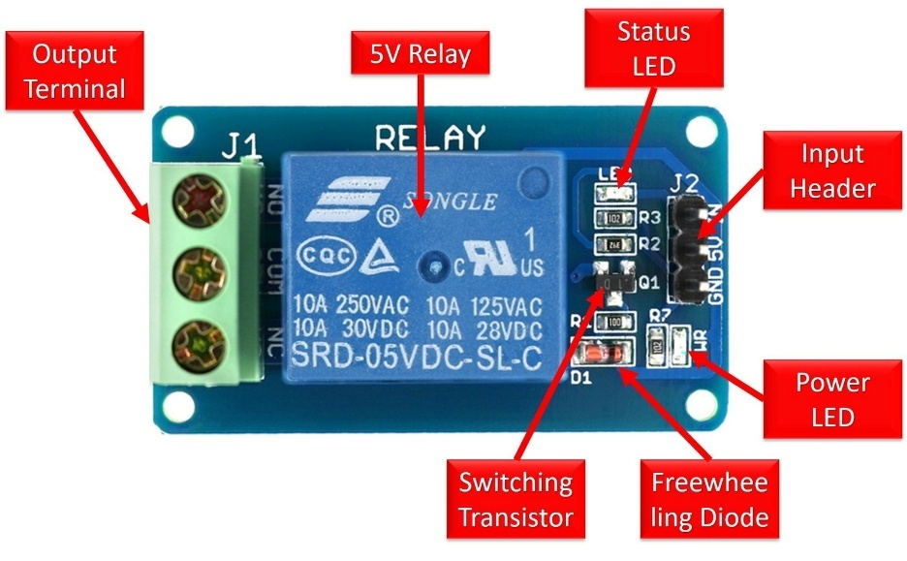

Active Buzzer Module
An Active Buzzer is an electronic sound-producing device that generates a beep sound when power is applied. It has a built-in oscillator circuit, which allows it to produce sound without requiring an external signal source.
Unlike a passive buzzer, an active buzzer only needs a DC voltage to operate, making it simple and easy to use in embedded systems.
Key Features:
- Built-in oscillator circuit
- Simple ON/OFF control
- Low power consumption
- Compact size
- Easy to interface with microcontrollers
- Stable sound output

Working Principle:
The active buzzer works based on an internal oscillator circuit.
- When voltage is applied:
  - The oscillator generates a square wave signal.
  - This signal drives a piezoelectric element.
  - The element vibrates and produces sound.
Operation:
- Power ON → Internal oscillator starts
- Oscillation → Piezo element vibrates
- Vibration → Sound (beep)

Technical Specifications:
Parameter | Specification
Operating Voltage | 3V – 5V (typical)
Rated Voltage | 5V
Current Consumption | 10–30 mA
Sound Output | ~85 dB (typical)
Frequency | 2 kHz – 4 kHz
Type | Active (self-oscillating)
Drive Method | DC signal

Pin Configurations
Pin | Description
VCC (+) | Power supply (3.3V–5V)
GND (−) | Ground
Advantages
- Very easy to use (no signal generation required)
- Low cost and widely available
- Requires minimal external components
- Provides instant audio feedback
- Suitable for embedded systems

Limitations
- Fixed frequency (cannot control tone)
- Limited sound variation
- Lower flexibility compared to passive buzzer
- Not suitable for generating melodies
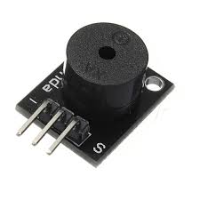

2.9 12V Li-ion Battery
A 12V Lithium-Ion (Li-ion) battery is a rechargeable energy storage device commonly used in portable electronics, electric vehicles, and embedded systems. It is made by connecting multiple lithium-ion cells in series to achieve a nominal voltage of approximately 12V.
Typically, a 12V Li-ion battery consists of 3 cells in series (3S configuration), where each cell has a nominal voltage of 3.7V, resulting in a total voltage of about 11.1V–12.6V when fully charged.
Working Principle
A Li-ion battery works based on electrochemical reactions between the anode and cathode.
- Anode (Graphite) stores lithium ions
- Cathode (Lithium metal oxide) releases lithium ions
- Electrolyte allows ion movement
Charging:
- Lithium ions move from cathode → anode

Discharging:
- Lithium ions move from anode → cathode
- Electrons flow through the external circuit → powering the system
Key Features
- High energy density
- Lightweight and compact
- Rechargeable (long cycle life)
- Low self-discharge rate
- No memory effect
- High efficiency

Technical Specifications:
Parameter | Specification
Nominal Voltage | 11.1V (3S configuration)
Fully Charged Voltage | 12.6V
Cut-off Voltage | ~9V
Capacity | 2000 mAh – 5000 mAh (typical)
Charge Current | 0.5C – 1C
Discharge Current | Depends on rating
Cycle Life | 300 – 500 cycles
Energy Density | High
Charging Method

Pin Configurations
Pin | Description
Positive (+) | Output supply terminal
Negative (−) | Ground terminal

Advantages
- Lightweight compared to lead-acid batteries
- High energy storage capacity
- Rechargeable with long lifespan
- Compact and portable
- Efficient power delivery

Limitations
- Requires protection circuit (BMS)
- Sensitive to overcharging and overheating
- Higher cost than traditional batteries
- Needs proper charging circuit

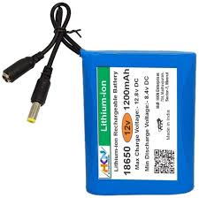

2.10 1000 RPM DC Motor
A 1000 RPM DC motor is a type of electric motor that converts electrical energy into mechanical rotation, operating at a speed of approximately 1000 revolutions per minute (RPM). It is widely used in robotics, automation, and embedded systems due to its simple control and reliable performance.

Working Principle
A DC motor works based on the principle of electromagnetic induction.
- When a DC voltage is applied:
    - Current flows through the armature winding.
    - A magnetic field is generated.
    - This interacts with the field magnets (permanent magnets).
    - A force is produced, causing rotation.
Key Features
- Fixed speed around 1000 RPM
- Simple ON/OFF control
- Reversible direction
- Compact size
- Easy to interface with controllers
- Suitable for low to medium load applications

Technical Specifications:
Parameter | Specification
Rated Voltage | 6V / 12V (common types)
Speed | 1000 RPM (no-load)
Current Consumption | 100 mA – 500 mA (no-load)
Stall Current | Higher (1A – 3A approx.)
Torque | Moderate
Power Rating | Depends on motor size
Shaft Diameter | ~3 mm – 6 mm
Motor Type | Brushed DC motor

Pin Configurations
Pin | Description
Positive (+) | Connect to power supply
Negative (−) | Negative (−) Connect to ground

Advantages
- Simple design and easy operation
- Low cost and widely available
- Easy speed control using PWM
- Reversible direction
- Suitable for beginners and embedded systems

Limitations
- Brush wear over time
- Limited efficiency compared to brushless motors
- Speed varies with load
- Generates electrical noise
- Requires motor driver for control

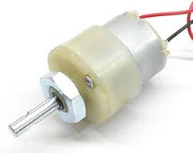

2.11 Arduino IDE
Arduino Integrated Development Environment - or Arduino Software (IDE) - contains a text editor for writing code, a message area, a text console, a toolbar with buttons for common functions and a series of menus. It connects to the Arduino hardware to upload programs and communicate with them.
Boards: The board selection has two effects: it sets the parameters (e.g., CPU speed and baud rate) used when compiling and uploading sketches; and sets and the file and fuse settings used by the burn bootloader command. Some of the board definitions differ only in the latter, so even if you've been uploading successfully with a particular selection, you'll want to check it before burning the bootloader. You can find different boards here.
Arduino Software (IDE) includes the built-in support for the boards in the following list, all based on the AVR Core. The Boards Manager included in the standard installation allows to add support for the growing number of new boards based on different cores like Arduino Due, Arduino Zero, Edison, Galileo and so on.

- Arduino Yin: An ATmega32u4 running at 16 MHz with auto-reset, 12Analog In, 20 Digital I/O and 7 PWM.
- Arduino Uno: An ATmega328P running at 16 MHz with auto-reset, Analog In, 14 Digital I/O and 6 PWM.
- Arduino Diecimila or Duemilanove w/ ATmega168: An ATmega168 running at 16 MHz with auto-reset.
- Arduino Nano w/ ATmega328P: An ATmega328P running at 16 MHz with auto- reset.
- Arduino Mega 2560: An ATmega2560 running at 16 MHz with auto- reset, 16Analog In, 54 Digital I/O and 15 PWM.
- Arduino Mega: An ATmega1280 running at 16 MHz with auto-reset, 16Analog In, 54 Digital I/O and 15 PWM.
- Arduino Mega ADK: An ATmega2560 running at 16 MHz with auto- reset, 16 AnalogIn, 54 Digital I/O and 15 PWM.

- Arduino Esplora: An ATmega32u4 running at 16 MHz with auto- reset.
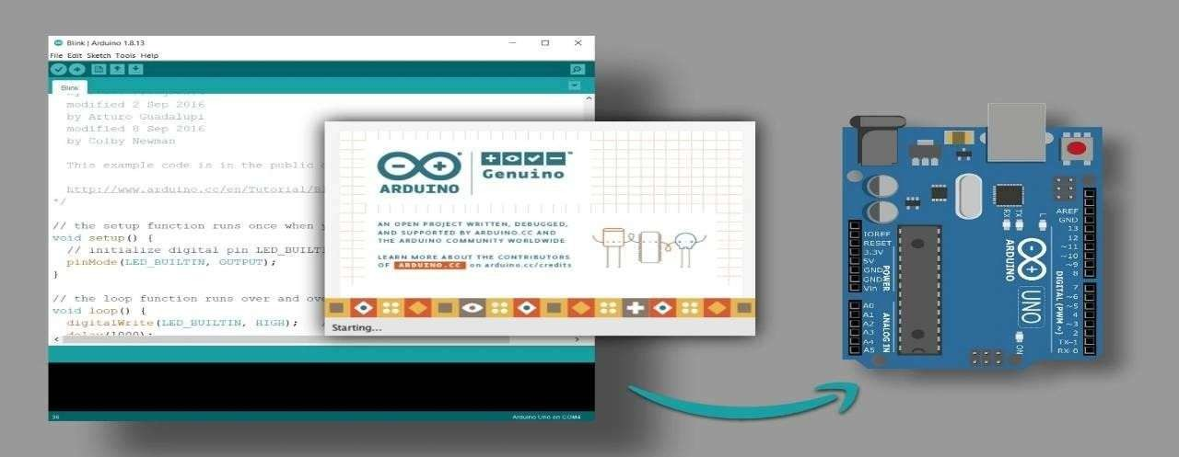
- Arduino Mini w/ ATmega328P: An ATmega328P running at 16 MHz with auto- reset, 8 Analog In, 14 Digital I/O and 6 PWM.

  - Arduino Ethernet: Equivalent to Arduino UNO with an Ethernet shield: An ATmega328Prunning at 16 MHz with auto-reset, 6 Analog In, 14 Digital I/O and 6 PWM.
  - Arduino Fio An ATmega328P running at 8 MHz with auto-reset. Equivalent to Arduino Pro or Pro Mini (3.3V, 8 MHz) w/ ATmega328P, 6 Analog In, 14 Digital I/O and 6 PWM.
  - Arduino BT w/ ATmega328P ATmega328P: running at 16 MHz the bootloader burned (4 KB) includes codes to initialize the on-board Bluetooth® module, Analog In, 14 Digital I/O and 6 PWM.

Libraries:
Libraries play a crucial role in providing additional functionality for interfacing hardware components and enabling communication in embedded systems. In the proposed Smart Rider Safety and Accident Detection System, several libraries are used to simplify complex operations such as sensor interfacing, wireless communication, GPS data processing, and cloud-based alert systems. The WiFi.h library is used to connect the ESP32 to a wireless network, which enables communication with the Twilio cloud service for sending SMS alerts. The esp_now.h and esp_wifi.h libraries are used to establish fast and reliable communication between the helmet unit and bike unit ESP32 modules using the ESP-NOW protocol without requiring internet connectivity.
For sending emergency alerts, the HTTPClient.h library is used to make HTTP requests to the Twilio API, while the base64.h library is used to encode authentication credentials for secure communication. The GPS module is interfaced using the TinyGPSPlus.h library, which processes latitude and longitude data, and the HardwareSerial.h library is used for UART communication between the ESP32 and the GPS module. Additionally, the Wire.h library enables I2C communication with the MPU6050 sensor, and the MPU6050.h library is used to read accelerometer and gyroscope data for accident detection. Other sensors such as the MQ-3 alcohol sensor, PIR motion sensor, and eye blink sensor are interfaced directly using GPIO pins without requiring dedicated libraries. All these libraries are included at the beginning of the program using #include statements, and they are compiled along with the code during upload, which increases memory usage; therefore, only essential libraries are utilized to ensure efficient system performance.

Serial Monitor:
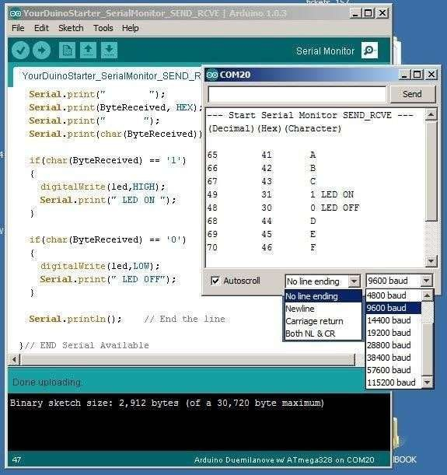
The The Serial Monitor in the Arduino IDE is used to display real-time data, debug messages, and system logs transmitted from the ESP32 using functions such as Serial.print() and Serial.println(). It plays an important role in monitoring sensor readings and verifying the system’s operation in the Smart Rider Safety and Accident Detection System. Through the Serial Monitor, developers can observe values such as alcohol levels from the MQ-3 sensor, drowsiness status from the eye blink sensor, helmet detection status from the PIR sensor, and accident detection data from the MPU6050. It is also useful for viewing GPS coordinates, Wi-Fi connection status, ESP-NOW communication logs, and Twilio message transmission details.

To open the Serial Monitor, select Tools > Serial Monitor or press Ctrl + Shift + M in the Arduino IDE. It is important to ensure that the baud rate set in the Serial Monitor matches the baud rate defined in the program (commonly 115200) to correctly display the data. The Serial Monitor is essential for debugging, testing, and validating the performance of the system during development.

APPLICATION CODE

Sender Code:
#include <WiFi.h>
#include <esp_now.h>
#include <Wire.h>
#include <MPU6050.h>
#include <esp_wifi.h>

#define HELMET_PIN 26
#define EYE_PIN 27
#define MQ3_PIN 34
#define SDA_PIN 21
#define SCL_PIN 22

#define ALCOHOL_THRESHOLD 800
#define ACC_THRESHOLD 2.5
#define EYE_CLOSE_TIME_MS 2000

uint8_t bikeMAC[] = {0xBC, 0xDD, 0xC2, 0xD1, 0xD6, 0xF4};

typedef struct {
uint8_t helmet;
uint8_t alcohol;
uint8_t eyeClosed;
uint8_t accident;
} helmet_data_t;

helmet_data_t data;
MPU6050 mpu;
unsigned long eyeCloseStartTime = 0;

void onSent(const uint8_t *mac_addr, esp_now_send_status_t status) {
Serial.print("Send status: ");
Serial.println(status == ESP_NOW_SEND_SUCCESS ? "Success" : "Fail");
}

void setup() {
Serial.begin(115200);

pinMode(HELMET_PIN, INPUT_PULLUP);
pinMode(EYE_PIN, INPUT_PULLUP);

Wire.begin(SDA_PIN, SCL_PIN);
mpu.initialize();

WiFi.mode(WIFI_STA);
WiFi.disconnect();
delay(100);

// Force fixed channel
esp_wifi_set_channel(1, WIFI_SECOND_CHAN_NONE);

if (esp_now_init() != ESP_OK) {
Serial.println("ESP-NOW init failed");
return;
}

esp_now_register_send_cb(onSent);

esp_now_peer_info_t peer = {};
memcpy(peer.peer_addr, bikeMAC, 6);
peer.channel = 1;
peer.encrypt = false;

if (esp_now_add_peer(&peer) != ESP_OK) {
Serial.println("Failed to add peer");
return;
}

Serial.println("Sender ready (channel 1)");
}

void loop() {

data.helmet = (digitalRead(HELMET_PIN) == HIGH);

int mq3Value = analogRead(MQ3_PIN);
data.alcohol = (mq3Value > ALCOHOL_THRESHOLD);

if (digitalRead(EYE_PIN) == LOW) {
if (eyeCloseStartTime == 0)
eyeCloseStartTime = millis();

if (millis() - eyeCloseStartTime >= EYE_CLOSE_TIME_MS)
data.eyeClosed = 1;
} else {
eyeCloseStartTime = 0;
data.eyeClosed = 0;
}

int16_t ax, ay, az;
mpu.getAcceleration(&ax, &ay, &az);

float Ax = ax / 16384.0;
float Ay = ay / 16384.0;
float Az = az / 16384.0;
float accMag = sqrt(Ax * Ax + Ay * Ay + Az * Az);

data.accident = (accMag > ACC_THRESHOLD);

esp_now_send(bikeMAC, (uint8_t*)&data, sizeof(data));

delay(500);
}

3.2 Receiver Code:
#include <WiFi.h>
#include <esp_now.h>
#include <esp_wifi.h>
#include <TinyGPSPlus.h>
#include <HTTPClient.h>
#include "base64.h"

#define RELAY_PIN 25
#define BUZZER_PIN 26
#define GPS_RX 16
#define GPS_TX 17

#define ACC_CONFIRM_TIME 800
#define HELMET_DEBOUNCE_TIME 300

/* ================= WIFI FOR TWILIO ================= */
const char* ssid = "lohi";
const char* password = "pranavi24";

/* ================= TWILIO CONFIG ================= */
const char* account_sid = "AC876b419b0c121adb0f3e39780d8e9f17";
const char* auth_token = "4074950f50b3002ca53d4992ede7e7b9";

String fromNumber = "+19893680062";

/* ===== MULTIPLE RECEIVER NUMBERS ===== */
String toNumbers[] = {
"+917675856779",
"+919542943919",
"+917093929388"
};

const int totalNumbers = sizeof(toNumbers) / sizeof(toNumbers[0]);
/* ================= GPS ================= */
HardwareSerial gpsSerial(2);
TinyGPSPlus gps;

/* ================= DATA STRUCTURE ================= */
typedef struct struct_message {
bool helmetWorn;
bool alcohol;
bool sleep;
bool accident;
} struct_message;

struct_message incomingData;

/* ================= STATE VARIABLES ================= */
bool accidentConfirmed = false;
bool accidentTimerRunning = false;
bool locationSent = false;
unsigned long accidentStartTime = 0;

bool stableHelmetWorn = false;
bool lastHelmetRead = false;
unsigned long helmetChangeTime = 0;

/* ================= SMS FUNCTION ================= */
void sendSMS(double lat, double lon) {

Serial.println("Connecting to WiFi for SMS...");
WiFi.begin(ssid, password);

unsigned long start = millis();
while (WiFi.status() != WL_CONNECTED && millis() - start < 10000) {
delay(500);
Serial.print(".");
}
Serial.println();

if (WiFi.status() == WL_CONNECTED) {

for (int i = 0; i < totalNumbers; i++) {

HTTPClient http;

String url = "https://api.twilio.com/2010-04-01/Accounts/" + String(account_sid) + "Messages.json";

http.begin(url);

String auth = String(account_sid) + ":" + String(auth_token);
String encodedAuth = base64::encode(auth);

http.addHeader("Authorization", "Basic " + encodedAuth);
http.addHeader("Content-Type", "application/x-www-form-urlencoded");

String mapsLink = "https://www.google.com/maps?q=" +
String(lat, 6) + "," +
String(lon, 6);

String messageBody =
"Accident+Detected%21"
"%0ALocation%3A+" + mapsLink;

String postData =
"To=" + toNumbers[i] +
"&From=" + fromNumber +
"&Body=" + messageBody;

int code = http.POST(postData);

Serial.print("SMS to ");
Serial.print(toNumbers[i]);
Serial.print(" | HTTP code: ");
Serial.println(code);

http.end();
delay(3000); // delay between messages
}

} else {
Serial.println("WiFi failed. SMS not sent.");
}

/* Return to ESP-NOW mode */
WiFi.disconnect(true);
delay(100);
esp_wifi_set_channel(1, WIFI_SECOND_CHAN_NONE);
Serial.println("Returned to ESP-NOW mode");
}

/* ================= RECEIVE CALLBACK ================= */
void onDataRecv(const uint8_t *mac,
const uint8_t *incomingDataRaw,
int len) {

if (len != sizeof(incomingData)) return;
memcpy(&incomingData, incomingDataRaw, sizeof(incomingData));

Serial.println("\n====== RECEIVED DATA ======");
Serial.print("Helmet worn : ");
Serial.println(incomingData.helmetWorn ? "YES" : "NO");

Serial.print("Alcohol detected: ");
Serial.println(incomingData.alcohol ? "YES" : "NO");

Serial.print("Eye closed long : ");
Serial.println(incomingData.sleep ? "YES" : "NO");

Serial.print("Accident signal : ");
Serial.println(incomingData.accident ? "YES" : "NO");

/* Helmet debounce */
bool currentHelmetRead = incomingData.helmetWorn;
if (currentHelmetRead != lastHelmetRead) {
helmetChangeTime = millis();
lastHelmetRead = currentHelmetRead;
}
if (millis() - helmetChangeTime >= HELMET_DEBOUNCE_TIME) {
stableHelmetWorn = currentHelmetRead;
}

/* Accident confirmation */
if (incomingData.accident && !accidentConfirmed) {
if (!accidentTimerRunning) {
accidentStartTime = millis();
accidentTimerRunning = true;
}

if (millis() - accidentStartTime >= ACC_CONFIRM_TIME) {
accidentConfirmed = true;
accidentTimerRunning = false;
locationSent = false;
Serial.println("Accident confirmed");
}
}

/* Reset after accident */
if (!incomingData.accident && accidentConfirmed) {
accidentConfirmed = false;
accidentTimerRunning = false;
accidentStartTime = 0;
locationSent = false;
Serial.println("System reset to normal");
}

/* ================= ENGINE CONTROL ================= */
if (accidentConfirmed) {
digitalWrite(RELAY_PIN, LOW);
Serial.println("Engine: OFF (Accident)");
}
else if (!stableHelmetWorn) {
digitalWrite(RELAY_PIN, LOW);
Serial.println("Engine: OFF (Helmet not worn)");
}
else if (incomingData.alcohol) {
digitalWrite(RELAY_PIN, LOW);
Serial.println("Engine: OFF (Alcohol detected)");
}
else {
digitalWrite(RELAY_PIN, HIGH);
Serial.println("Engine: ON");
}

/* ================= BUZZER ================= */
if (incomingData.sleep) {
digitalWrite(BUZZER_PIN, HIGH);
Serial.println("Buzzer: ON (Drowsiness)");
} else {
digitalWrite(BUZZER_PIN, LOW);
Serial.println("Buzzer: OFF");
}
}

/* ================= SETUP ================= */
void setup() {
Serial.begin(115200);

pinMode(RELAY_PIN, OUTPUT);
pinMode(BUZZER_PIN, OUTPUT);

digitalWrite(RELAY_PIN, LOW);
digitalWrite(BUZZER_PIN, LOW);

gpsSerial.begin(9600, SERIAL_8N1, GPS_RX, GPS_TX);

WiFi.mode(WIFI_STA);
WiFi.disconnect();
delay(100);

esp_wifi_set_channel(1, WIFI_SECOND_CHAN_NONE);

Serial.print("Receiver MAC: ");
Serial.println(WiFi.macAddress());

if (esp_now_init() != ESP_OK) {
Serial.println("ESP-NOW init failed");
return;
}

esp_now_register_recv_cb(onDataRecv);
Serial.println("Receiver ready (channel 1)");
}

/* ================= LOOP ================= */
void loop() {

while (gpsSerial.available()) {
gps.encode(gpsSerial.read());
}

/* Send SMS once after accident */
if (accidentConfirmed && !locationSent && gps.location.isValid()) {

double lat = gps.location.lat();
double lon = gps.location.lng();

Serial.println("\n=== ACCIDENT LOCATION ===");
Serial.print("Latitude : ");
Serial.println(lat, 6);
Serial.print("Longitude: ");
Serial.println(lon, 6);

sendSMS(lat, lon);
locationSent = true;
}
}

IMPLEMENTATION DIAGRAM

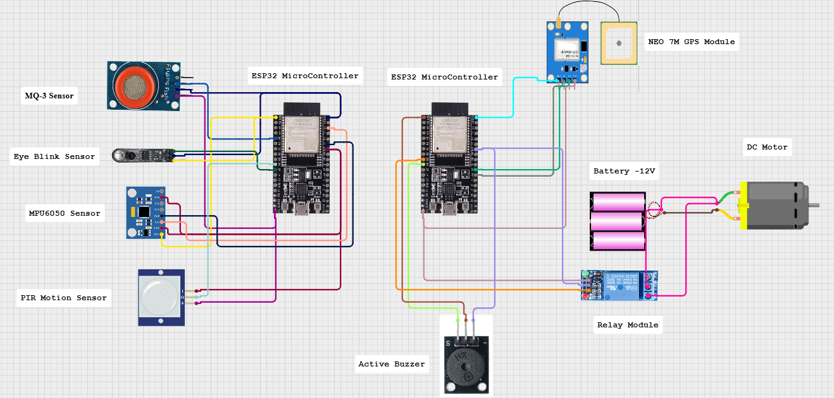
Schematic Diagram

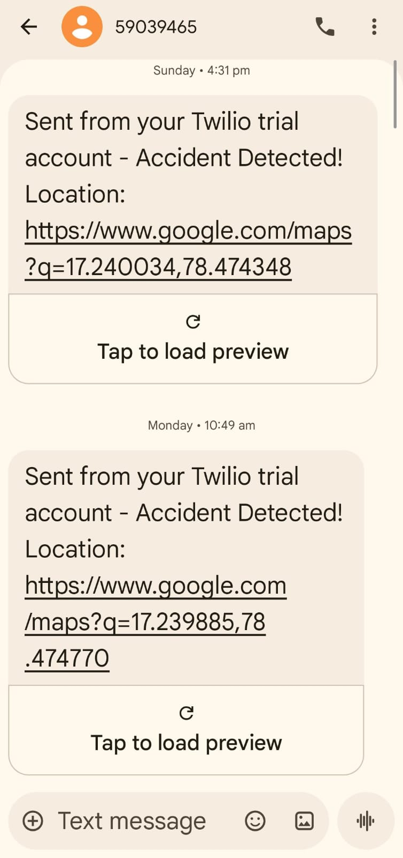
Cloud Output

5 Flow of the Project Work

1. System Startup
i. ESP32 modules (Helmet Unit & Bike Unit) power ON
ii. Initialize all hardware components:
Helmet Unit:
- PIR Motion Sensor (Helmet detection)
- MQ-3 Alcohol Sensor
- MPU6050 (Accident detection)
- Eye Blink Sensor
- Buzzer
Bike Unit:
- GPS Module (NEO-7M)
- Relay Module (Engine control)
- DC Motor (Engine simulation)
- Buzzer
iii. Establish ESP-NOW communication between Helmet ESP32 and Bike ESP32
iv. Bike ESP32 connects to Wi-Fi
v. Configure Twilio API for SMS service
vi. System displays/indicates: “SYSTEM READY – WEAR HELMET”
vii. System enters monitoring mode

2. Idle State (Monitoring Mode)
- System continuously monitors:
  - Helmet wearing status
  - Alcohol level
  - Drowsiness condition
  - Accident detection
- ESP-NOW communication remains active
- Engine remains in OFF state initially

3. Helmet Detection Flow (PIR Sensor)
i. PIR sensor detects presence of rider inside helmet
ii. Decision:
- If helmet NOT detected:
  - Engine remains OFF
  - Warning condition generated
- If helmet detected:
  - System proceeds to next validation

4. Alcohol Detection Flow (MQ-3 Sensor)
i. MQ-3 sensor reads alcohol concentration
ii. Decision:
- If alcohol detected:
  - Engine is kept OFF (initial stage)
  - Warning alert generated
- If no alcohol:
  - System proceeds further

5. Engine Control Logic
IF (Helmet = YES) AND (Alcohol = NO)
→ Engine ON (Relay activated)
ELSE
→ Engine OFF

6. Drowsiness Detection Flow (Eye Blink Sensor)
i. Eye blink sensor continuously monitors rider eye movement
ii. Decision:
- If drowsiness detected:
  - Buzzer is activated
  - Buzzer remains ON until rider wakes up
- If normal condition:
  - No alert

7. Communication Flow (ESP-NOW)
- Helmet ESP32 sends real-time sensor data to Bike ESP32
- Communication is fast and does not require internet

8. Accident Detection Flow (MPU6050)
i. MPU6050 monitors:
- Sudden impact
- Abnormal tilt
ii. Decision:
- If accident detected:
  - Engine immediately turned OFF
  - Emergency process triggered

9. Emergency Alert System
i. GPS module retrieves current location (Latitude & Longitude)
ii. Bike ESP32 connects to Wi-Fi
iii. Sends data to Twilio Cloud
iv. SMS is sent to emergency contacts containing:
- Accident alert message
- Location coordinates

10. Buzzer & Safety Alerts
- Activated during:
  - Drowsiness detection
  - Unsafe conditions
- Provides real-time warning to rider

11. System Recovery & Continuous Monitoring
- System continuously monitors all conditions
- ESP-NOW communication maintained
- GPS updated continuously
- System remains ready for emergency detection

12. Continuous Operation
- System loops back to monitoring state
- Ensures real-time safety checks
- Always ready for next detection event

LITERATURE SURVEY
The proposed Smart Rider Safety and Accident Detection System focuses on developing an integrated safety platform using ESP32 microcontrollers, sensor modules (such as MPU6050, MQ-3, PIR, and Eye Blink sensor), and IoT-based communication for real-time monitoring, accident detection, and emergency alert systems. The following table presents a structured literature survey highlighting existing methods, technologies, applications, and their limitations.
S. No. | Title / Authors | Technology / Method | Application / Remarks | Limitations / Challenges
1 | Accident Detection System Using GPS and GSM | Accelerometer + GPS + GSM | Detects accidents and sends location via SMS | High cost, GSM dependency, no preventive safety features
2 | IoT-Based Vehicle Accident Detection System | IoT + Cloud + Sensors | Real-time accident monitoring and alert system | Requires continuous internet connection, higher power consumption
3 | Smart Accident Detection Using MPU6050 | Accelerometer + Gyroscope | Detects sudden impact and abnormal motion | Only post-accident system, no prevention mechanism
4 | Proposed System: Smart Rider Safety and Accident Detection | ESP32 + ESP-NOW + MPU6050 + MQ-3 + PIR + Eye Blink + GPS + Twilio | Integrated system combining helmet detection, alcohol detection, drowsiness monitoring, and accident alert with real-time SMS notification | Requires proper calibration, sensor accuracy dependency, and reliable Wi-Fi for alert transmission

CONCLUSION
The Smart Rider Safety and Accident Detection System successfully demonstrates how embedded systems and Internet of Things (IoT) technologies can be integrated to enhance road safety for two-wheeler riders. By utilizing ESP32 microcontrollers as the core processing units, along with multiple sensors such as MPU6050, MQ-3, PIR, and eye blink sensors, the system provides a reliable and real-time safety monitoring solution. The use of ESP-NOW communication enables fast and efficient data transfer between the helmet unit and bike unit without requiring continuous internet connectivity, ensuring low latency and reliable operation.
The proposed system significantly improves rider safety by incorporating preventive as well as reactive mechanisms. It prevents unsafe riding conditions by ensuring that the rider is wearing a helmet and has not consumed alcohol before starting the vehicle. Additionally, it monitors rider alertness using an eye blink sensor and provides warning alerts in case of drowsiness. In the event of an accident, the system automatically detects abnormal motion using the MPU6050 sensor and sends an emergency alert message along with the rider’s location through the GPS module and Twilio cloud service. This reduces response time and increases the chances of timely medical assistance.
From an implementation perspective, the system is cost-effective, compact, and suitable for real-world deployment. It uses readily available components and open-source development platforms, making it easy to develop and maintain. The ESP32 acts as a powerful and efficient controller, handling sensor data processing, wireless communication, and cloud integration simultaneously. The modular design of the system also allows future enhancements such as mobile application integration, advanced AI-based drowsiness detection, cloud data analytics, and improved communication technologies without major hardware modifications.
In conclusion, the proposed Smart Rider Safety System provides a practical, scalable, and intelligent solution for improving two-wheeler safety. By combining accident prevention, real-time monitoring, and automatic emergency response, the system contributes to reducing accident-related fatalities and highlights the importance of IoT and embedded systems in developing smart transportation and safety solutions.

REFERENCES
- A. M. Syedul, J. Jalil and M. Reaz, "Accident detection and reporting system using GPS, GPRS and GSM technology," International Conference on Informatics, Electronics and Vision, pp. 640-643, 2012.
- https://srituhobby.com/mq3-alcohol-sensor-arduino-code-step-by-step-instructions/#google_vignette
- Anthony, M., Varia, R., Kapadia, A., & Mukherjee, M. (2021). Alcohol detection system to reduce drunk driving. International Journal of Engineering Research & Technology (IJERT), 9(3), NTASU Conference Proceedings.
- M. Rehan Ozbayoglu, M., Kucukayan, G., & Dogdu, E. (2017). A real-time autonomous highway accident detection model based on big data processing and computational intelligence, arXiv preprint, arXiv:1712.09227.
- Pathik, N., Gupta, R. K., Sahu, Y., Sharma, A., Masud, M., & Baz, M. (2022). AI enabled accident detection and alert system using IoT and deep learning for smart cities. Sustainability, 14(13), 7701.
- Kare, S. S., Bhandalkar, D. T., Ankamwar, A.A., Jagtap, S. M., & Deokate, N. A. (2023). Accident detection and alert system using deep learning. International Journal of Progressive Research in Science and Engineering, 4(5), 215–217.

